Project Design Phase-II
Technology Stack (Architecture & Stack)

Date | 8 October 2026
Team ID | SWTID-2026-3520
Project Name | Implement Client Script & UI Policy (Incident)
Maximum Marks | 4 Marks

Technical Architecture:
The Deliverable shall include the architectural diagram as below and the information as per the table1 & table 2
Architecture: Client Script & UI Policy on the ServiceNow Incident form
Guidelines:
Include all the processes (As an application logic / Technology Block)
Provide infrastructural demarcation (Local / Cloud)
Indicate external interfaces (third party API’s etc.)
Indicate Data Storage components / services
Indicate interface to machine learning models (if applicable)
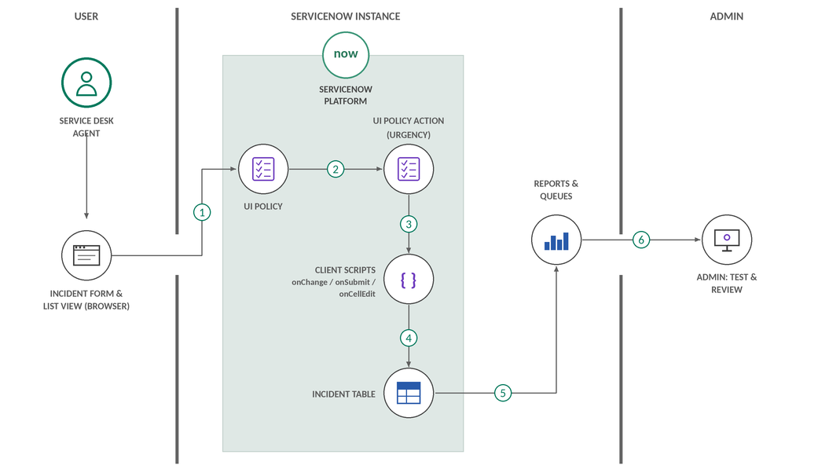

Table-1 : Components & Technologies:
S.No | Component | Description | Technology
 | User Interface | Agents and fulfillers use the ServiceNow Incident form and list view in a web browser. | ServiceNow Next Experience UI (Incident form and list view), HTML / CSS, Google Chrome
 | Application Logic-1 | UI Policy and UI Policy Action on the Incident form: make fields mandatory, visible or read-only; Urgency policy action. | ServiceNow UI Policy (condition builder, UI Policy Actions)
 | Application Logic-2 | Client Scripts: onChange (react to value changes), onSubmit (save validation) and onCellEdit (list edit validation). | ServiceNow Client Scripts, JavaScript (g_form, g_user, g_list APIs)
 | Application Logic-3 | Testing and debugging of the configuration with sample incidents and different users. | Impersonate User, Script Debugger, browser console (Chrome DevTools)
 | Database | Incident table (incident) stores the validated incident records; UI Policy and Client Script records are stored in the platform tables. | ServiceNow platform relational database (Incident table)
 | Cloud Database | Database service provided by the ServiceNow cloud instance; no separate database setup is needed. | ServiceNow cloud instance (hosted database)
 | File Storage | Incident attachments and project screenshots; configuration changes are moved with update sets. | ServiceNow Attachments (sys_attachment), Update Sets
 | External API-1 | Not required: all processing runs inside the ServiceNow instance. | Not applicable (internal GlideForm client API only)
 | External API-2 | Not required: no third-party service is called. | Not applicable
 | Machine Learning Model | Not applicable: the project uses rule-based UI Policies and Client Scripts. | Not applicable
 | Infrastructure (Server / Cloud) | Application deployment on the ServiceNow cloud instance, accessed through a browser.  Local Server Configuration: not required; a laptop with Google Chrome is the client.  Cloud Server Configuration: ServiceNow Personal Developer Instance (PDI) hosted by ServiceNow. | ServiceNow cloud (PDI)

Table-2: Application Characteristics:
S.No | Characteristics | Description | Technology
 | Open-Source Frameworks | Client-side logic is written in standard JavaScript on the ServiceNow platform; no separate open-source framework is installed. | JavaScript (ES5) with the ServiceNow GlideForm client API
 | Security Implementations | Access is controlled by user roles and ACLs. Client Scripts and UI Policies guide data entry on the client, while the instance enforces access on the server. | Role-based access control, ACLs, HTTPS / TLS, ServiceNow authentication
 | Scalable Architecture | Multi-tier platform (browser client, application tier, database tier); rules are reusable and can be extended to more fields and tables. | ServiceNow cloud multi-tier architecture, reusable UI Policies and Client Scripts
 | Availability | The configuration runs on the ServiceNow cloud, a managed and redundant platform, so the form rules are available whenever the instance is up. | ServiceNow cloud platform (managed hosting, high availability)
 | Performance | Client-side checks respond instantly without a server round trip; UI Policies are preferred where possible and scripts avoid unnecessary server calls. | UI Policy, lightweight Client Scripts, no synchronous GlideRecord queries on the client

